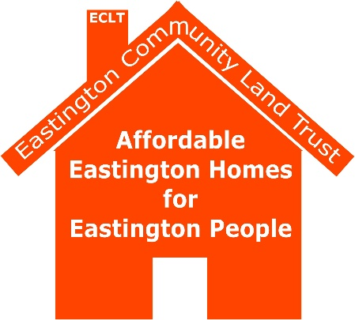
Eastington Community Land Trust Ltd. (ECLT)
116th Meeting of Board Members
Village Hall 7.00 pm
Thursday 7th July 2022

Minutes
1. Attendance: Tom Morrison (Chair) (TM), Muriel Bullock (Vice Chair) (MB), Martin Elliot (ME), Lynne Farnden (Treasurer) (LF), Alan Brasier (AB), Tom Low (Secretary) (TL), Nicola Rowlings (NR).
Apologies: Tim Crane (TC), Cllr John Jones (JJ), Anthea McCann (AM),).
Declarations of Interest: none

2. Approval of Minutes
The minutes of Board Meeting of 16th June 2022 were approved and signed by MB, chair of that meeting.

3. Financial and Administration Report

3.1 Invoices
There were two invoices and the balance at bank would be £66,646.11 after all payments have cleared.

3.2 Update on expenditure on CHF Grant
TL reported that the final legal invoices received by 30th June (and now paid) ensured that the balance of the CHF Grant had been expended. There remains £2,600 in Budget 1300 ring-fenced for Project Two and over £7,000 in the General Fund Budget 710. However, there are no significant bills outstanding for Project Two due to monies being lodged with our solicitor in expectation of all known financial commitments for the S 106.

4. Project Two

4.1 Update on exchange of contracts
The landowners have now suggested a Longstop date based on Planning Permission but with an Ultimate Date based upon Exchange of Contracts. TM explained this remains mainly a matter for 2RH, since it affects viability. This implies that 2RHwill require confidence in the imminence of Planning Permission (see 4.3 below).

4.2 Update on S 106
TM reported that the S 106 draft had been received from SDC but that there were a series of technical items to be tidied up which made the document awkward for Trustees to read.
There was a discussion about the cascade for Shared Ownership units, which TM and TL had been trying to improve. The draft S 106 appeared to have the cascade in the wrong place and Trustees agreed that the cascade should be identical for both rented and shared ownership units. TM and TL would reflect this in the draft before sending it to 2RH for their comments.
ACTIONS: TM, TL
LF suggested that 2RH attend the next Board, in order to ensure all remaining S 106 matters were agreed, prior to reversion to SDC. This was agreed.
ACTION: TL

4.3 Progress on planning application
TL reported that there had been two significant developments. Firstly SDC had declared a deadline for all statutory consultees to reply by 5th July and there had been no significant issues raised. The only outstanding queries lay with National Highways who had now responded on all their original points with a mixture of acceptance, requests of Conditions and further queries. SDC agreed to deal with one query, which was around noise abatement and so not strictly a matter for National Highways at all.
In consort with Quattro, TL had checked the various Conditions were reasonable, leaving Quattro to respond to National Highways via SDC on the remaining issues. This was turned around in 24 hours because all the answers were already available and should not take National Highways long to agree.
It remained for TL to double-check the requested Conditions with 2RH (sent July 8th).

5. Update on grassed areas at Fullers Close
ME observed Mr Haines had continued removing the large thistles and docks from the orchard area and that Aster had been cutting the large, grassed area in the centre of the estate.
MB reported that Aster had agreed to pay for renovation of the garden of number 23, adjacent to the orchard but that this may take Mr Haines some time to fit into his schedule.

6. Date of next meeting
The next meeting was agreed as 21st July at 7.00 pm in the Village Hall. TM gave his apologies.

Meeting closed at 7.50 pm
Tom Low Secretary
July 2022

Glossary

2RH Two Rivers Housing Association
CHF Community Housing Fund – source of government grant run by Locality
EPC Eastington Parish Council
GCC Gloucestershire County Council
GM Ground Maintenance (Aster or 2RH)
LEMP Landscape and Ecology Management Plan
S 106 Section 106 – legal document between SDC, ECLT and 2RH, mainly on lettings and local/family connections
SDC Stroud District Council

