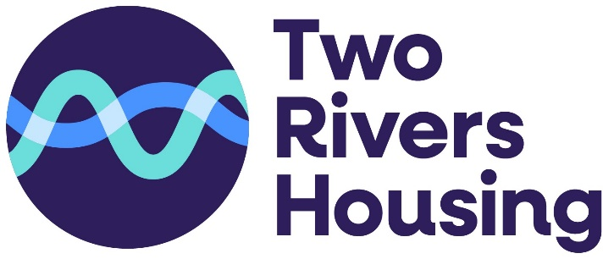
Applying for Share ownership in Homeground Eastington
What is Shared Ownership? Shared Ownership is an affordable way to buy your own home. With Shared Ownership you can part-rent and part-buy a property. If you have a regular income but cannot afford current house prices, Shared Ownership could help start you on the road to full home ownership. Two Rivers Housing will retain the share of the property you do not buy and you will be charged a rent on this share.
How does Shared Ownership work? If you bought a home on the open market, you would agree a purchase price through an estate agent. Then you would take out a mortgage to cover the total purchase price of the property minus any deposit you might have available. With Shared Ownership, the price of the property is fixed at the open market value, as assessed by a qualified valuer. You borrow enough to cover the share you are buying. This is referred to as equity share. The equity share amount will be an amount that you can afford, as set out under government guidelines and agreed with our panel of mortgage brokers.
Who is eligible?
- You must be unable to afford to purchase 100% of a property on the open market
- You must have a close local connection to Eastington - You must currently live/work in the area, have close relatives in the area or have grown up there. We will ask you to demonstrate your connection.
- Your affordability for the property must be assessed by one of our panel of mortgage brokers. This advice will be provided free of charge. If you then go on to take out a mortgage with them a fee would become payable.
- Your household must earn less than £80,000 per annum.
- You cannot own any other property.
- You must live in the property as your ONLY and principal home.
Shared Ownership pros and cons
The pros
- You could buy sooner because of the smaller deposit and mortgage
- It’s more affordable for those on a lower income
- You can increase your share in the property as and when you can afford it
- It’s available on new-build homes and existing properties
The cons
- Shared Ownership properties are leasehold, rather than freehold, so you will not own the land the property is on
- You have to pay service charge that comes with the property regardless of how big your stake is
- When you come to sell, you may have to do it through the Shared Ownership scheme rather than on the open market
- Buying more of the property over time comes at a cost
How to apply
- You need to complete this application form Shared ownership application

- We will need to see we need to see: Photo ID, Proof of address and you need to demonstrate your local connection.

- You need to seek financial advice from one of our panel of mortgage brokers who will assess your affordability. You need to say that you have been referred by Two Rivers Housing. They will do this assessment for free

Brunswick Homeloans  Persh Farm, Persh Lane  Maisemore, Gloucester,  GL2 8HH  Tel: 01452 413300  http://www.brunswickhomeloans.co.uk/  service@brunswickhomeloans.co.uk | TMP – The Mortgage People  1-2 Grafton Court, Kettering Parkway,  Kettering Venture Park, Kettering,  Northamptonshire, NN15 6XR  Tel: 0800 4880 814  https://tmpmortgages.co.uk/  chirpy@tmpmortgages.co.uk

Shared ownership allocation policy

The demand for our shared ownership homes far outstrips the supply, it is therefore imperative that we are clear in how we allocate and offer our shared ownership homes to prospective eligible customers.

In line with regulative guidance we have to be open in offering our shared ownership homes on a first come first served basis.

Our first come first serve policy at Two Rivers Housing is based upon;

Whoever is first to pass their assessment and submit all their documents and meet any local connection criteria.

Adverse policy

From time to time there will be customers who will have experienced circumstances beyond their control and have had a history of bad credit. We will consider these applicants based on their personal circumstances guided by the following

Missed mortgage/rent arrears | If this has happened in the last 12 months, it won’t usually be accepted. That said, we may consider the situation through an individual assessment with one of our approved IFAs
Unsecured arrears | An individual assessment needs to be carried out by one of our approved IFAs
County Court Judgments or registered  defaults | None in the last 36 months. Plus, they must be satisfied prior to the mortgage application. They may be acceptable in the following situations:  • All CCJs/defaults were registered more than three years ago and satisfied prior to mortgage application.  • All CCJs/defaults were satisfied more than 12 months prior to application regardless of date of registration.  • The CCJs/defaults in aggregate amount to less than £300, regardless of date of registration, and were satisfied prior to mortgage application.
Individual voluntary arrangement (IVA)  and discharged bankrupts | IVA/bankrupts who have been discharged over three years ago and who have no residual debt may be accepted subject to individual assessment with one of our approved IFAs
Repossessions | Not acceptable.

